SPARK: Simple Play Adaptations to Reference for Kids

Jiobit Gen 3 - GPS Tracker for Kids
Description: | Image:
Jiobit is 1.96 x 1.45 x 0.47 inches and weighs 0.8 ounces. It easily and discreetly attaches to clothing, shoes, backpacks, etc. The Jiobit is paired with a caregiver's smartphone to deliver real-time location information that will track in any location at any distance, and includes Alert Notification, Location History, Geo-Fence, Real Time Tracking, and SOS with unlimited nationwide range. The Jiobit tracker requires 1 Lithium Polymer battery (included) and requires a subscription data plan to stay connected. During activation in the free Jiobit app, choose between monthly and annual plans. No additional SIM or cellular plan needed. Compatible with Android and Apple devices. | 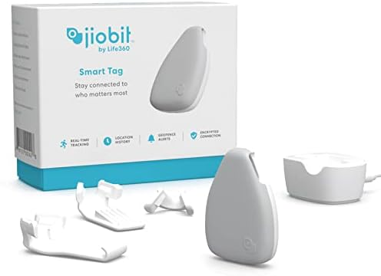  Purchasing Information

Who Might Benefit
Those who…
• Are responsible for supervising children.
• Act on impulse and try to leave the area at home, school, daycare, and in the community.
• Attempt to follow another individual leaving the area.

Why Use?
Provides an opportunity to…
• Acts as a safety measure for those who try to leave an area due to:
• Becoming overstimulated in the classroom, at home, or in the community
• Wandering from supervised areas
• Being frightened or upset
• Attention Seeking
Instructions for Use: | Adaptation Ideas:
Environmental Considerations  - Create boundaries such as a taped box in front of the doorway as a “no stand zone”.  - Place the desk or table where the teacher spends the most class time close to the door to allow for quick intervention.  - Place a stop sign on door or outside gate.  Positioning  - Place the child away from an accessible door. If possible, have an adult positioned close to the child as well as the door to redirect them if they try to leave.  Basic Play/Use  - Be sure Jiobit is fully charged.  - Attach to clothing, shoes, backpacks, etc., that remains with the individual.  - Track with data plan and personal device.  - Jiobit Subscription Plan: The Jiobit tracker requires a subscription data plan to stay connected. During activation in the free Jiobit app, choose between monthly and annual plans. No additional SIM or cellular plan needed. Compatible with Android and Apple devices  Play/Use with Others  - Create a poster about leaving the area to be reviewed daily in morning circle/meeting, as well as posted on or near the door as a reminder to children who struggle with elopement.  - Combine posters or social stories about leaving designated areas with community signs/traffic lights with concepts of stop (red light), go (green light), wait or caution (yellow light).  - Play Red Light Green Light game and discuss instances of when it is important to stop, and OK to go. | Communication Support  Visuals displaying options of things children can say or do when they feel like they need to "get away".  - Create lanyards for all staff with visuals including stop, wait, I need a break.  - Create an individual or class Social Story (e.g., Staying with My Class, Running Away, I Can Choose to Be Safe)  DIY Alternatives  - “Sleigh bells” or other movement triggered noise maker on doors and gates.  - Stop signs posted on doors and gates.

Resources:
- See Social Narratives from OCALI’s Autism Center Grab and Go Resource Gallery of Interventions.
- For further information, visit the Social Narratives Autism Internet Module.
- Like Social Stories, Power Cards teach and reinforce academic, behavioral, organizational, and social skills. Power Cards are visual supports that include an individual’s special interest. See Power Cards from OCALI’s Autism Center Grab and Go Resource Gallery of Interventions.
- Reminder Cue Cards from OCALI’s Autism Center Grab and Go Resource Gallery of Interventions help teach and remind individuals how to engage in positive behaviors. Reminder Cue Cards provide “what to do” suggestions when an individual is feeling anxious, stressed, or confused. They also support interactions with peers, and offer ways to self-regulate, and manage emotions.

Ohio Early Learning Standards:

SS. People, Communities, and their Environment: Develops understanding that everyone has rights and responsibilities within a group (1.c.).
- PD&W. Wellness: Demonstrates increasing understanding of safety practices and behaviors (2.f.).

Words to Encourage Play/Use
Stop | Go | Wait
Open | Close | Help
Sad | Mad | Scared
*”Adaptations” adapted from: Haugen’s Modes for Adapting Toys based on materials from the "Let's Play" Project at the University of Buffalo
PCS is a trademark of Tobii Dynavox, LLC. All rights reserved. Used with permission.

